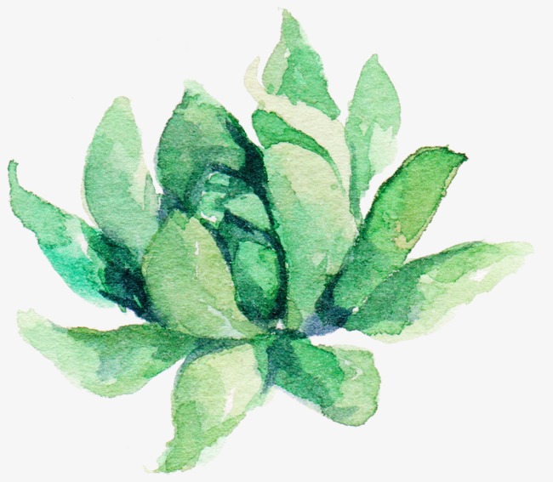

Sacred Planting:
Earth Wisdom Through Book of Exodus
This worship series reflects on the earthly wisdom found in the mythological stories in the Book of Exodus. Through the use of imagery and tying it to these ancient stories, we find new perspectives on how we can live a life filled with joyous intent as we cultivate the gardens of our faith.

Companion Planting
“No one has ever become poor by giving.” Anne Frank
Companion planting is an ancient form of agriculture utilized in the Americas for millienia. The corn is considered the “pole” up which the beans climb, while the beans help fertilize the corn with nitrogen from below. The third element, the squash, spreads on the ground and helps nourish these plants by protecting form weeds and improving water retention. These three plants are called the “Three Sisters” in much of Native America.
From Wikipedia:Native Americans throughout North America are known for growing variations of Three Sisters gardens.^{[8]} The milpas of Mesoamerica are farms or gardens that employ companion planting on a larger scale.^{[9]} The Ancestral Puebloans are known for adopting this garden design in a drier environment. The Tewa and other peoples of the Southwestern United States often included a "fourth Sister", Rocky Mountain bee plant (Cleome serrulata), which attracts bees to help pollinate the beans and squash.^{[10]}
Companion planting not only made sense agriculturally, but nutritionally too. In the absence of meat, these three plants when eaten together are complete proteins humans need to thrive.
Scripture: 10 Commandments
Song: For the Beauty of the Earth
Children’s Time: Book: In the Three Sisters Garden: Native American Traditions Myths and Culture by Jack Peduzzi, JoAnne Dennee, and Julia Hand. Here we introduce the worship series, and give kids the pots to color for next time, discussing plan to sew our own seeds to be chosen next time.
Poem: Now is the Time by Hafiz
Sermon Themes: Theophany or the appearance of God in text as well as our lives; the history of the Jewish people and their ancestral stories that are not just Biblical stories but Human Stories. The appearance of God as a deity directs them towards rising above through concrete dictates such as the 10 commandments. Our souls require multiple ways to help us grow. The 10 commandments as a moral scaffolding for the Three Sisters.

Images for inspiration:
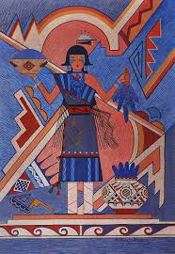
From https://www.firstpeople.us/native-art/Gilbert-Atencio-Blue-Corn-Maiden.html
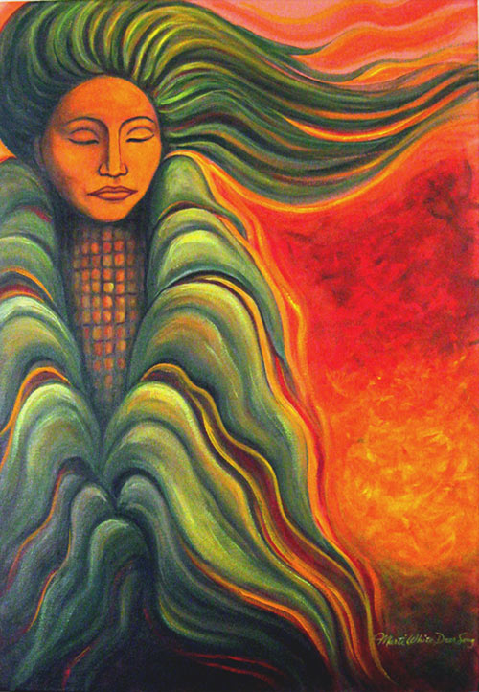
From https://journeyingtothegoddess.wordpress.com/2012/08/12/goddess-selu/

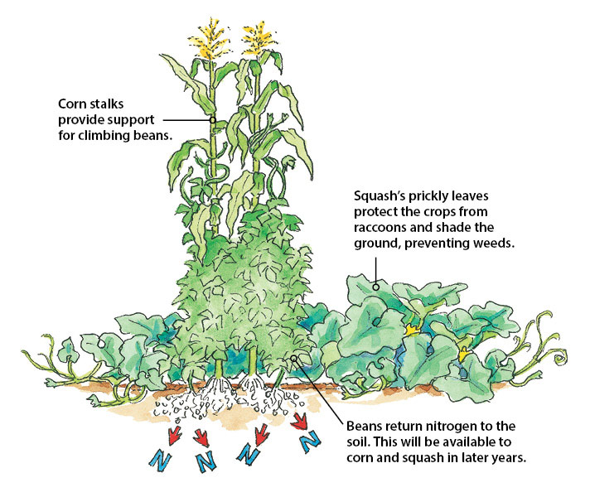
From https://www.gardengatemagazine.com/articles/vegetables/tips/beneficial-companion-planting/

Nurturing Our Soil
“Injustice anywhere is a threat to justice everywhere.” MLK Jr.
Scripture: Manna from Heaven
Song: Where Charity and Love Prevail
Children’s Time: Kids bring back pots that have been colored, we place soil in it and talk about soil. Give three examples of soil (from forest, from farm, from backyard) and note the differences. Discuss how we can take care of the earth, like recycling or saving water, and share how this helps take care of earth’s people.
Poem: Memesis by Fady Joudah
Sermon Themes: God will provide. What will we do with what God provides? We are challenged by governments or laws or customs or fears that often whisper to us not to follow our faith. We are called to be the manna, but often are sowers of our own discord. God even left manna for those who were “wicked”, not just the “righteous.” How do we choose to nurture ourselves and our communities? How do we resist the “walls” that we erect, both figuratively and literally? How do we become refugees from our faith when we ignore the calls of the poor, the refugees? What is our faith community doing to nurture others, even those with whom we disagree or dislike?
Images for the Week:
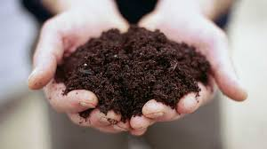

From https://www.southernliving.com/home-garden/gardens/secret-to-perfect-soil

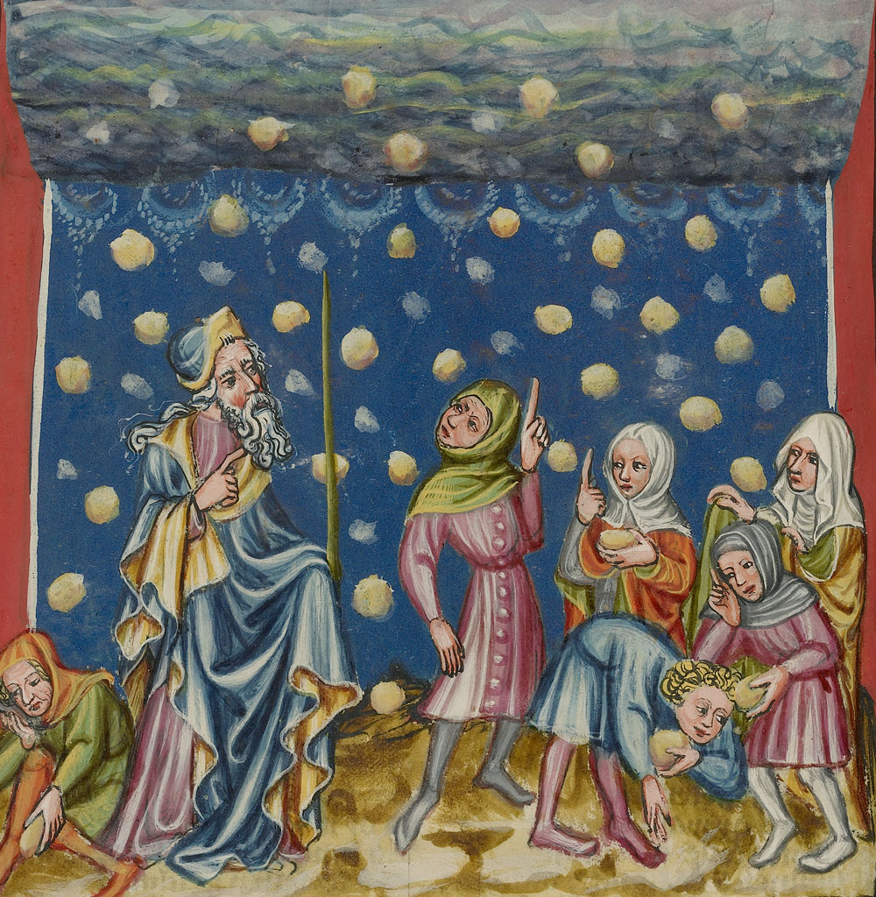
From http://www.santospiritomerano.it/scuola-della-parola-13-318-la-manna/

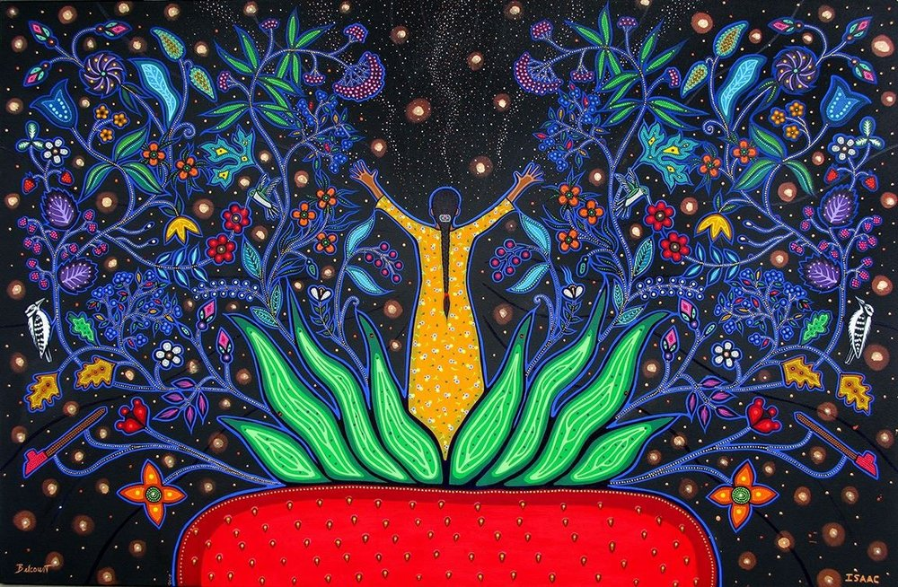
New Beginnings by Christi Belcourt and Isaac Murdoch, 2016 https://www.reddit.com/r/Art/comments/5abyxj/new_beginnings_christi_belcourt_and_isaac_murdoch/
Suppressing the Weeds
“Weeds are flowers too, once you get to know them.” Winnie the Pooh
Scripture: Building of the temples/tabernacle
From Wikipedia for historical reference:
According to the Tanakh, the tabernacle (Hebrew: מִשְׁכַּן‎, mishkan, "residence" or "dwelling place") was the portable earthly dwelling place of Yahweh among the children of Israel from the time of the Exodus from Egypt through the conquering of the land of Canaan. Built of woven layers of curtains along with 48 boards overlaid with polished gold standing like vertical blinds held in place by five bars per side with the middle bar shooting through from end to end and furnished with items made from the gold, silver, brass, furs, jewels, and other valuable materials taken out of Egypt at Yahweh's orders, and according to specifications revealed by Yahweh to Moses at Mount Sinai, it was transported ^{[1]} by the Israelites on their journey through the wilderness and their conquest of the Promised Land. Solomon's Temple in Jerusalem superseded it as the dwelling-place of God some 440 years later.
Song: Gentle Spirit Deep Within
Children’s Time: In the kids’ pots, choose a seed to plant. Talk about what types of plants (flowers for beauty, herbs to flavor, vegetables to sustain) Option: read story Weeds in Nana’s Garden by Katherine Harrison
Poem: The Scarecrow by Kahlil Gibran
Sermon Themes: Who fills our lives with beauty so that unhealthy thoughts or patterns don’t take root? We are faced daily with challenges that keep our attention away from our breath, from our spirit, from our calling to do the work of following Christ’s Way. The story from Exodus shows us the challenges of facing higher authorities, the historical basis for some of Jesus’ work when he was here on earth. What resistance have we faced when we have turned from the American shrines of injustice or greed? What do we turn to when we are scared, worried, uncertain?
Images for the week:
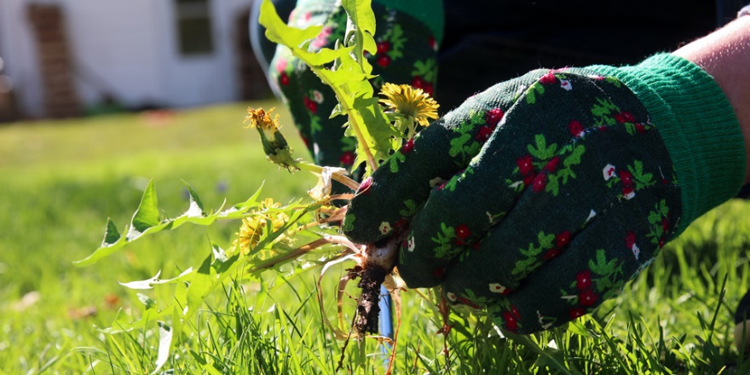
From https://www.bunnings.com.au/diy-advice/garden/planting-and-growing/how-to-control-weeds-organically
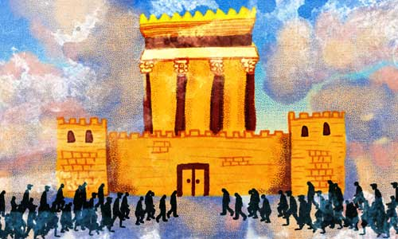
From https://www.chabad.org/parshah/article_cdo/aid/3948916/jewish/Building-a-Temple-for-Gd-Today.htm
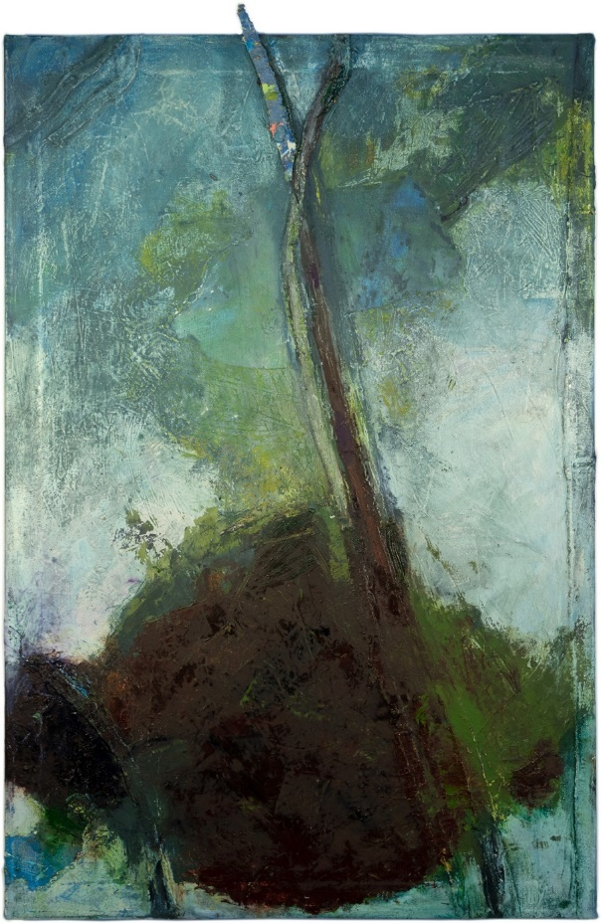
From https://www.portlandmercury.com/events/22052601/weeds

Managing the Pests
“Fear is the natural reaction to moving closer to the truth.” Pema Chodron
Scripture: Plague of Locusts
Song: Halleluiah
Children’s Time: Native American (Cherokee) Story: How the Honeybees Got their Stinger. (https://www.firstpeople.us/FP-Html-Legends/HowTheHoneyBeeGotTheirStinger-Cherokee.html)
Discuss the story, the tendency for us to be fearful of something that actually is helpful. Check on the seeds and see if any have sprouted.
Poem: At the Teahouse, 6am by Holly J. Hughes
Sermon Themes: We are often afraid of what we don’t understand. The locust plague is a natural phenomenon, like most of the plagues that mythological stories attempt to understand. Our science has gotten better and clarified natural reasons for plagues, such as unchecked ecological imbalances that cause locust populations to soar. Human influence causes destruction such as importing invasive species, wildfires, mining, farming, etc. We are the locusts today. What are our responsibilities to ourselves and our future? How do we move from fear to a place of working together to make the world a better place? (Rev Barber, Poor People’s Campaign)

Images for the week:
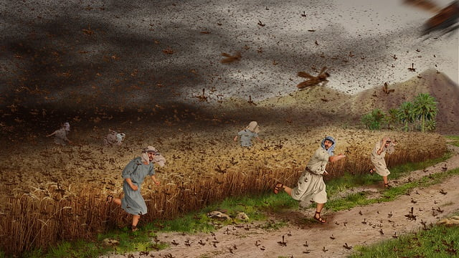
From https://www.rainbowtoken.com/exodus-10-the-eighth-plague-locusts.html

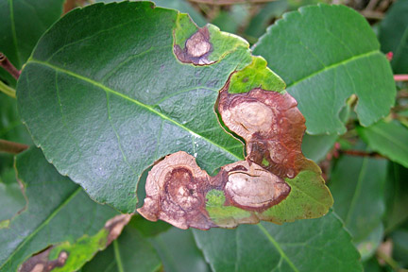
From https://www.rhs.org.uk/advice/profile?PID=342

Irrigating the Spirit
“Art enables us to find ourselves and lose ourselves at the same time.” Thomas Merton
Scripture: Parting of the Red Sea
Song: When Peace, Like a River
Children’s Time: Give each child a small watering can for their seeds. Show them how to water the seeds and talk about what other things they can water (plants at home). Discuss how rain or drought happens in our lives, abundance and scarcity.
Poem: A Gift by Denise Levertov
Sermon Themes: The biblical story highlights God’s power in freeing his children. How do we loosen our grips on our egos, our fears, and allow got to free us from our inner exile? Art and music is often the place where our minds are able to take a break from intellectualizing. How can we use strategies like this to bring us to a sense of closeness to God, Spirit, and each other?

Images for the week:
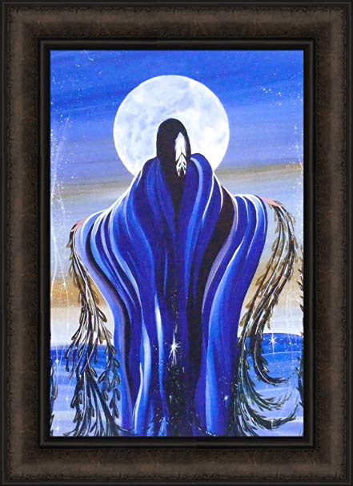
August Moon by Betty Albert (https://www.amazon.com/August-Albert-Native-American-Picture/dp/B071DT2Z7N)
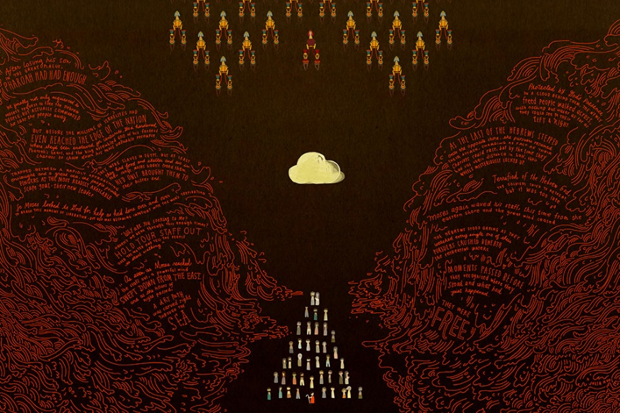
Parting of Red Sea by Julia Kuo (oldandnewproject.com)

Harvesting Our Bounty
“The source of all abundance is not outside of you. It’s a part of who you are.” Eckhart Tolle
Scripture: Golden Calf
Song: Canticle of the Sun
Children’s Time: Today we take our seeds and split them into new pots. Now we have over two times more plants than we started with! The kids then give the pots to people they choose in the congregation. Option: Read Let the Whole Earth Sing With Praise by Tomie dePaola
Poem: “May the sun bring you new energy every day.
May the moon softly restore you by night.
May the rain wash away your worries.
May the breeze blow new strength into your being.
May you walk gently through the world
and know its beauty all the days of your life.”

Apache prayer

Sermon Themes: Review the weeks that culminate in our harvest. Recognize the harvesting that God does in the biblical story of the Calf, and that it reflects how the people of that time –found in both Islamic and Jewish mythology—highlighted the importance of community over personal wealth. We can reflect on how this has parallels in today’s America. How do we move outward with our sprouting seeds when we know, deep down, in a cosmic, spiritual sense, that there is always enough?

Images for the Week:
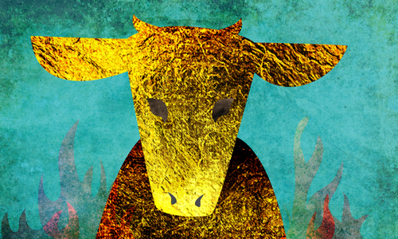
From https://www.chabad.org/library/article_cdo/aid/3613047/jewish/What-Was-the-Golden-Calf.htm

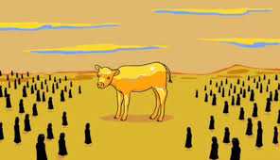
From http://lbc.ac.uk/golden-calf/
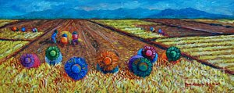
By Paul Hilario, Nilaga Stew (https://fineartamerica.com/featured/nilaga-stew-paul-hilario.html)

